SIMATS ENGINEERING
CO3 - ASSESSMENT TOOL - 2: Case Study

COURSE NAME: | Cloud Computing and Big Data Analytics | COURSE CODE: | CSA1522
Name | KEERTHANA.L
Register Number | 192521062

COURSE OUTCOME COVERED
CO3: Implement cloud-based solutions using cloud storage, web APIs, and platform services for real-world applications. (BL3)

Dave's Taxonomy: Precision (Level 3)  Question Count: 3 | Total Marks: 30

Code of Conduct
I KEERTHANA –(192521062)(Name / Reg No) certify that this submission is my original work and that I have adhered to the guidelines specified for this assessment.
I understand that any violation of academic integrity rules will result in disciplinary action.
Signature of the student: KEERTHANA.L-(192521062)
Assessment Tasks - Case Study
- Case Study 1: Smart Retail Inventory Management System
A retail chain implements a cloud-based inventory system connected to store devices. Clients (POS systems and dashboards) communicate via APIs to centralized cloud services. Cloud storage stores product data, transaction logs, and analytics datasets. The system uses platform services for analytics and demand forecasting. Secure access is maintained through VPNs, firewalls, and API gateways. This solution integrates infrastructure, services, and web applications for efficient operations.

- Case Study 2: Cloud-Based Document Collaboration System
An enterprise deploys a document collaboration tool similar to Google Docs. Users access the platform via browsers, enabling real-time editing and sharing. Documents are stored in distributed cloud storage with version control mechanisms. Web APIs enable synchronization across multiple clients and devices.
Network infrastructure ensures low latency and high availability globally. Security includes encryption, identity management, and access permissions for collaboration.
- Case Study 3: Online Food Ordering Platform

A startup builds a cloud-based food ordering system accessible via web browsers and mobile clients.
Frontend clients interact with backend services through RESTful Web APIs hosted on a cloud platform.
Cloud storage is used to store menu images, invoices, and customer data securely. The infrastructure uses virtual machines and managed Kubernetes for scalability and reliability. Security is enforced through authentication tokens, HTTPS, and role-based access control. The system demonstrates integration of clients, APIs, storage, and platform services in real time.

Case Study Rubric
Criteria | Weightage | Level 4 - Exemplary | Level 3 - Proficient | Level 2 - Developing | Level 1 - Beginning
Understanding of Case | 25% | Clearly identifies all technical and business requirements | Identifies most requirements | Basic understanding only | Poor understanding of case
Application of Concepts | 25% | Applies suitable cloud concepts and tools effectively | Good application with minor issues | Partial application | Weak or incorrect application
Analysis | 20% | Strong analysis with clear trade-off reasoning | Reasonable analysis | Limited analysis | Minimal analysis
Solution Design | 20% | Solution is feasible, practical, and well justified | Reasonable solution with minor gaps | Basic solution | Unclear solution
Clarity | 10% | Well-structured and easy to follow | Mostly clear | Somewhat unclear | Poorly organized

1.Case Study 1: Smart Retail Inventory Management System
A retail chain implements a cloud-based inventory system connected to store devices. Clients (POS systems and dashboards) communicate via APIs to centralized cloud services. Cloud storage stores product data, transaction logs, and analytics datasets. The system uses platform services for analytics and demand forecasting. Secure access is maintained through VPNs, firewalls, and API gateways. This solution integrates infrastructure, services, and web applications for efficient operations.

Smart Retail Inventory Management System
1. Business Situation
A retail chain operates multiple stores and handles a large number of products and daily transactions. Each store generates sales, stock, and product information through POS systems. Managing this information separately can cause delays in stock updates, difficulty in tracking inventory, and problems in identifying products that need to be restocked.
To solve these problems, the retail chain implements a cloud-based inventory management system that connects all stores to centralized cloud services.
2. Cloud-Based Approach
The proposed system uses cloud computing to collect, process, store, and analyze inventory information from different stores. POS systems and management dashboards communicate with centralized cloud services through Web APIs.
An API Gateway manages incoming requests and provides controlled access to cloud services. Cloud compute services process the sales and inventory information, while cloud storage maintains product details, transaction logs, and analytics datasets.
The stored information is analyzed using cloud platform services. Analytics helps identify sales patterns and inventory trends, while demand forecasting predicts future product requirements. Managers can view the results through a centralized dashboard and take appropriate inventory decisions.

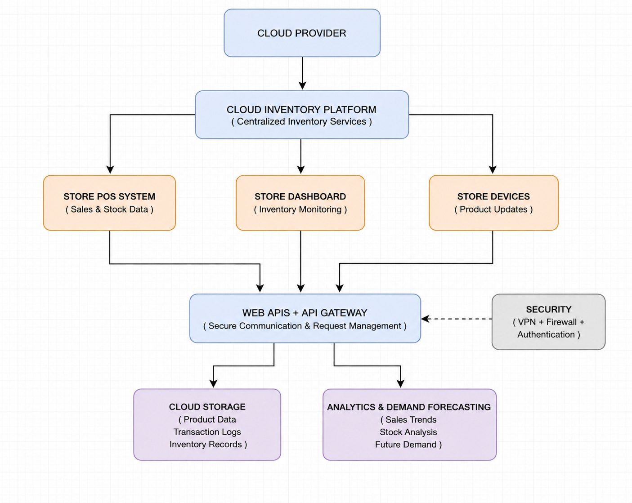

3. Technology Mapping
Requirement | Cloud Technology | Purpose
Sales and stock collection | POS Systems | Collect store-level information
Data communication | Web APIs | Transfer information to cloud services
API management | API Gateway | Control and secure API requests
Data processing | Cloud Compute | Process inventory and transaction data
Data management | Cloud Storage | Store products, transactions, and datasets
Data analysis | Analytics Services | Identify sales and inventory trends
Future planning | Demand Forecasting | Predict product requirements
Business monitoring | Dashboard | Display stock and analytics results

4. Security and Reliability
Security is important because the system handles business and transaction information. VPNs provide secure communication between stores and cloud services, while firewalls protect the cloud infrastructure from unauthorized network access.
The API Gateway controls API requests and helps prevent unauthorized access. Authentication and encryption can also be used to protect sensitive information. Cloud infrastructure provides scalability and allows the system to support additional stores and increasing numbers of transactions.
5. Business Impact
The proposed system provides several advantages to the retail chain:
- Centralized monitoring of inventory across multiple stores.
- Faster access to sales and stock information.
- Better identification of low-stock products.
- Reduced chances of overstocking and product shortages.
- Improved demand prediction using analytics.
- Secure communication between stores and cloud services.
- Easy expansion when new stores are added.
- Better decision-making through real-time dashboards.
The major advantage of using cloud computing is centralized and scalable inventory management. Instead of maintaining separate inventory systems for every store, all stores can use common cloud services and shared storage.
Cloud analytics also provides better insight into customer purchasing patterns and product demand. However, the system depends on reliable internet connectivity and cloud availability. Therefore, proper security, backup mechanisms, and reliable network infrastructure are required.
Overall, the advantages of scalability, centralized storage, analytics, accessibility, and secure communication make the cloud-based approach suitable for the retail chain.
6. Final Outcome
The proposed Smart Retail Inventory Management System provides a secure, centralized, and scalable solution for managing inventory across multiple stores. By integrating POS systems, Web APIs, API Gateway, cloud storage, cloud services, analytics, and demand forecasting, the retail chain can improve stock management, reduce inventory problems, and make faster business decisions.

2.Case Study 2: Cloud-Based Document Collaboration System
An enterprise deploys a document collaboration tool similar to Google Docs. Users access the platform via browsers, enabling real-time editing and sharing. Documents are stored in distributed cloud storage with version control mechanisms. Web APIs enable synchronization across multiple clients and devices.Network infrastructure ensures low latency and high availability globally. Security includes encryption, identity management, and access permissions for collaboration.

Cloud-Based Document Collaboration System
1. Case Overview
An enterprise needs a cloud-based document collaboration system that allows employees to create, edit, and share documents from different locations and devices. Users access the platform through web browsers and can work on the same document in real time.
The system stores documents in distributed cloud storage and uses version control to maintain previous changes. Web APIs help synchronize document updates between multiple users and devices.
2. Requirements / Problem
- The enterprise requires a system that can:
- Allow multiple users to edit documents in real time.
- Provide access through browsers and different devices.
- Store documents securely in the cloud.
- Synchronize changes between users.
- Maintain previous versions of documents.
- Provide high availability and low network latency.
- Control who can view, edit, or share documents.
- Protect documents from unauthorized access.
3. Proposed Cloud Solution
The proposed solution uses a cloud-based collaboration platform connected to distributed cloud storage. Users access the application through browsers or other client devices.
When a user opens or edits a document, the request is sent to cloud services through Web APIs. The cloud platform processes the changes and synchronizes them with other connected users. Updated documents are stored in cloud storage, while version control maintains the history of changes.
The system uses global network infrastructure to provide fast access and high availability for users in different locations.
4. System Working / Flow
User Devices → Web Application → Web APIs → Cloud Collaboration Services → Distributed Cloud Storage
From the cloud collaboration services:
Real-Time Synchronization → Other Connected Users
and
Document Changes → Version Control → Previous Document Versions
This allows multiple users to work on the same document while keeping the document data synchronized.

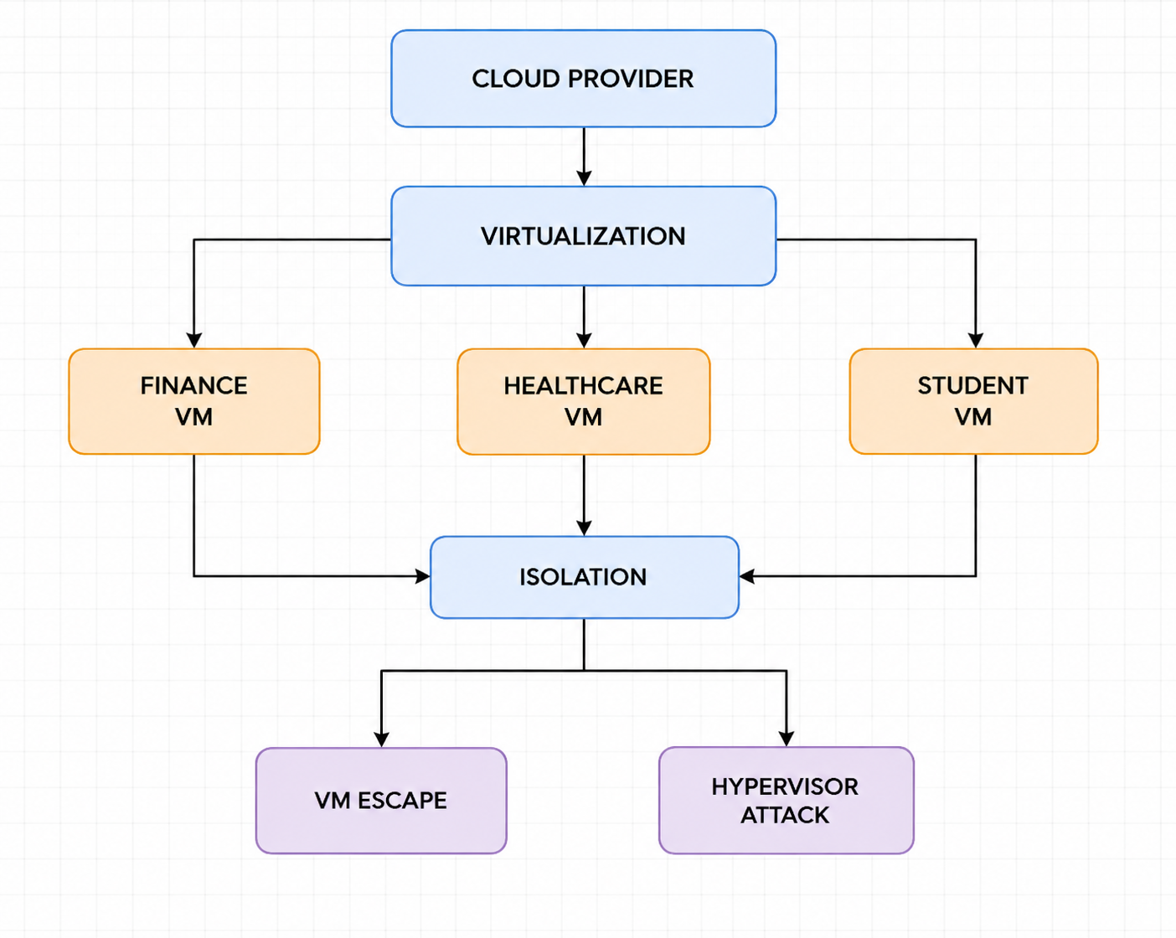
5. Cloud Components
Component | Purpose
Web Browsers / Client Devices | Allow users to access and edit documents
Web APIs | Synchronize document data between clients and cloud services
Cloud Collaboration Services | Process real-time editing and sharing
Distributed Cloud Storage | Store documents and related data
Version Control | Maintain previous versions of documents
Network Infrastructure | Provide low latency and high availability
Identity Management | Verify and manage user identities
Access Permissions | Control viewing, editing, and sharing rights

6. Security
Security is maintained using encryption, identity management, authentication, and access permissions. Encryption protects documents during transmission and storage. Identity management verifies users before they access the platform.
Access permissions can provide different levels of access. For example, one employee may have editing permission, while another may have view-only permission. This prevents unauthorized users from modifying confidential documents.

7. Benefits and Analysis
The cloud-based system allows employees to collaborate on documents from different locations without sending multiple copies of files. Real-time synchronization makes changes available to other users quickly.
Distributed cloud storage improves availability, while version control allows users to view or restore earlier versions. The system can also support a large number of users by using scalable cloud resources.
However, real-time collaboration depends on reliable network connectivity and efficient synchronization. Managing a large number of simultaneous users can also increase cloud resource usage.
Overall, real-time collaboration, centralized storage, scalability, high availability, and secure access make the cloud-based solution suitable for enterprise document management.
8. the overall Conclusion is:
The Cloud-Based Document Collaboration System combines Web APIs, cloud collaboration services, distributed cloud storage, version control, and security services to provide real-time document sharing and editing. The solution enables employees to collaborate efficiently from different devices while maintaining document security, availability, and previous versions.
3.Case Study 3: Online Food Ordering Platform
A startup builds a cloud-based food ordering system accessible via web browsers and mobile clients.
Frontend clients interact with backend services through RESTful Web APIs hosted on a cloud platform.Cloud storage is used to store menu images, invoices, and customer data securely. The infrastructure uses virtual machines and managed Kubernetes for scalability and reliability. Security is enforced
Online Food Ordering Platform
1. Case Overview
A startup wants to develop a cloud-based food ordering platform that allows customers to browse menus, place orders, make payments, and track their orders using web browsers and mobile applications.
The platform uses RESTful Web APIs to connect frontend clients with backend cloud services. Cloud storage is used for menu images, invoices, and customer information. Virtual machines and managed Kubernetes provide scalability and reliability as the number of users and orders increases.
2. Requirements / Problem
- The startup requires a system that can:
- Allow customers to browse food menus.
- Support online ordering through web and mobile clients.
- Connect frontend and backend services using RESTful APIs.
- Store customer, invoice, and menu information securely.
- Handle a large number of users and orders.
- Scale during high-demand periods.
- Provide reliable and continuous service.
- Protect customer and transaction information.
3. Proposed Cloud Solution
The proposed solution uses a cloud-based backend platform connected to web browsers and mobile applications.
Customers interact with the frontend to view menus and place orders. These requests are sent to backend services through RESTful Web APIs. Cloud services process the orders and store required information in cloud storage.
Virtual machines provide computing resources, while managed Kubernetes manages and scales application containers according to the workload. This allows the platform to handle increased orders during busy periods.The processed order information can then be accessed by the customer and restaurant through the appropriate application interfaces.
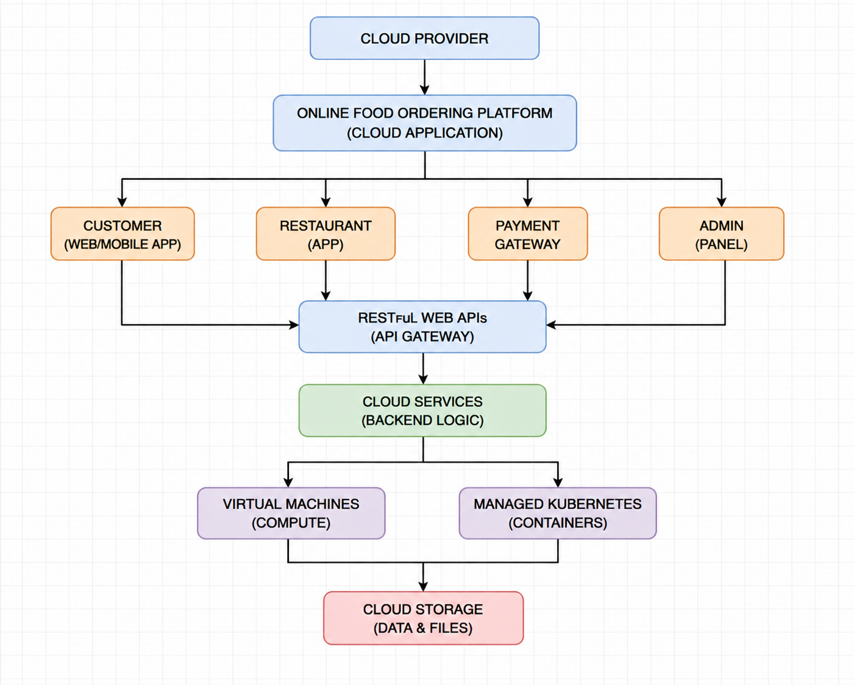

4. Cloud Components
Component | Purpose
Web Browser / Mobile Client | Allows customers to access the food ordering platform
RESTful Web APIs | Connects frontend clients with backend services
Cloud Backend Services | Processes customer requests and orders
Virtual Machines | Provide computing resources for applications
Managed Kubernetes | Manages and scales application containers
Cloud Storage | Stores customer data, invoices, and menu images
Authentication Tokens | Verify authorized users
HTTPS | Protects communication between clients and services
Role-Based Access Control | Controls access for customers, restaurants, and administrators

5. Security
Security is maintained using authentication tokens, HTTPS, and role-based access control (RBAC).
Authentication tokens verify users before they access protected services. HTTPS encrypts communication between the client and cloud platform. RBAC provides different permissions based on user roles. For example, a customer can place and view orders, while a restaurant can manage menus and update order status.
The cloud-based approach allows the startup to serve customers through both web and mobile applications using a common backend. RESTful APIs provide flexible communication between different clients and cloud services.
Virtual machines provide the required computing resources, while managed Kubernetes helps scale the application when order traffic increases. Cloud storage provides centralized and reliable storage for menu images, invoices, and customer information.
However, the system requires proper management of cloud resources and security controls. High traffic during peak ordering periods may also increase cloud usage and operational costs.
Overall, scalability, reliability, API-based communication, centralized storage, and flexible cloud infrastructure make this solution suitable for an online food ordering platform.
6. Conclusion
The Online Food Ordering Platform combines web and mobile clients, RESTful Web APIs, cloud backend services, virtual machines, managed Kubernetes, and cloud storage to provide a scalable and reliable ordering system. Security mechanisms such as authentication tokens, HTTPS, and role-based access control protect users and business data. The cloud-based solution allows the startup to handle changing workloads while providing continuous service to customers.

